**PROJECT REPORT**

**ON**

**HEALTHGENIC**

**Online Doctor Consultation and E-Health Commerce platform**

**Carried Out at**



**CENTRE FOR DEVELOPMENT OF ADVANCED COMPUTING**

**ELECTRONIC CITY, BANGALORE**

**UNDER THE SUPERVISION OF**

**Mr. VISHAL SINGH**

**C-DAC Bangalore**

**Submitted By**

**Akshay Agrawal (210951920009)**

**Kanishka Kumari (210951920041)**

**Lekha Gaikwad (210951920045)**

**Mahesh Divate (210951920049)**

**Mahima Choudhary (210951920050)**

**Ajay Shinde (210951920095)**

**PG DIPLOMA IN ADVANCED COMPUTING**

**C-DAC, BANGALORE**

**Candidate’s Declaration**

We hereby certify that the work being presented in the report entitled **Health-Genic – Online Doctor Consultation and E-Commerce platform,** in partial fulfillment of the requirements for the award of PG Diploma Certificate and submitted in the department of PG-DAC of the C-DAC Bangalore, is an authentic record of our work carried out during the period, 1st March 2022 to 13 Apr 2022 under the supervision of **Mr. Vishal Singh**, C-DAC Bangalore. The matter presented in the report has not been submitted by us for the award of any degree of this or any other Institute/University.

**(Name and Signature of Candidate)**

Akshay Agrawal (210951920009)

Kanishka Kumari (210951920041)

Lekha Gaikwad (210951920045)

Mahesh Divate (210951920049)

Mahima Choudhary (210951920050)

Ajay Shinde (210951920095)

**Counter Signed by**

--------------------

**ACKNOWLEDGMENT**

We take this opportunity to express our gratitude to all those people who have been directly and indirectly with us during the competition of this project.

we pay thanks to Mr. Vishal Singh who has given guidance and a light to us during this major project. His versatile knowledge about “MERN STACK and SDLC “has eased us in the critical times during the span of this Final Project.

we acknowledge here out debt to those who contributed significantly to one or more steps. We take full responsibility for any remaining sins of omission and commission.

**Students Name**

Akshay Agrawal ----------(210951920009)

Kanishka Kumari ---------(210951920041)

Lekha Gaikwad -----------(210951920045)

Mahesh Divate ------------(210951920049)

Mahima Choudhary ------(210951920050)

Ajay Shinde ---------------(210951920095)

**CERTIFICATE**

This is to certify that the work titled **Health-Genic – Online Doctor Consultation and E-Commerce platform** is carried out by Akshay Agrawal (210951920009), Kanishka Kumari (210951920041), Lekha Gaikwad (210951920045), Mahesh Divate (210951920049), Mahima Choudhary (210951920050), Ajay Shinde (210951920095) the bonafide students of Diploma in Advanced Computing of Centre for Development of Advanced Computing, Electronic City, Bangalore from 21 Sep 2021 – 16 Apr 2022. The Course End Project work is carried out under my direct supervision and 100% completed.

**Mr. Vishal Singh**

C-DAC #68, Electronic City,

Bangalore - 560100, India

**ABSTRACT**

Online medical services are growing across the world rapidly due to the COVID-19 pandemic. Realizing you have a health issue that needs medical attention and treatment can cause anxiety. Instead of visiting the doctor and describing your symptoms in order to receive treatment, seeing a doctor online for any kind of periodical consultations seems to be a great option now.

Health-Genic is a web-based application allows users to search nearby doctors, Hospitals, Book appointment with doctors and also, they can purchase & order medicines on one click. It is a platform where users have a one stop Solution for their all-health needs.

Health-Genic Application provides following functionalities to user: -

1.Book Appointment with doctors

-One on One video consultations with doctors

-Medical Advices through chats

2.Buy medicines

-Buy Health products

3.Connect with diagnostic labs

4.Medical advices in form of Blogs, videos

5.Maintaining patient health data for doctor convenience.

**TABLE OF CONTENT**

1. Introduction …..........................................................................................................................1

2. Literature Survey.......................................................................................................................3

3. Software Requirement Specification………………………………………………………....4

3.1 Product Perspective………… …………………………………………………........4

3.2 Specific Requirements…………………………………………………………….…7

4. Architecture………………………………………………………………………………......10

4.1:- 3 tier Application Architecture..…………………………………………………...10

4.2 Logical Tiers Of 3 tier Application ..…………………………………………….…10

4.2.1 Presentation Tier…………………………………………………………………..10

4.2.2. Logical Tier………………………………………………………………………10

4.2.3 Data Tier ...……………………………………………………………………......11

5. System Design…………………………………………………………………………….....10

5.1 Project Perspective………………………………………………………………....12

5.2 Use case Model Survey.………………………………………………………...….12

5.3 Actors Documentation……………………………………………………………...12

5.4 Diagrams……………………………………………………………………………13

6. Implementation…………………………………………………………………………….... 17

6.1 Homepage …………………………………………... ……………………………..17

6.1.2 Login……………………………………………………………………………...18

6.1.3 User Registration……………………………………………………………….....19

6.2 E-Pharma…………………………………………………………………………....19

6.2.1 Shop by Category…………………………………….………………………..….20

6.2.2 Select Your Item ……………………………………………………………….....20

6.2.3 Add to cart……………………………………………………………………..….20

6.2.4 Checkout for payment………………………………………………………….....21

6.2.5 Payment………………………………………………………………………...... 21

6.2.6 Payment Done ………………………………………………………………….....22

6.3 Find Doctor……………………………………………………………………….....22

6.3.1 Find Doctor by City ……………………………………………………………….23

6.3.2 Book Your Appointment ………………………………………………………….23

6.4 Video Consultation ………………………………………………………………….24

6.4.1 Video Consultation ………………………………………………………………..25

7. Conclusion… ……….…………………………………………...…………......…….….........25

8. References……………………………………………………………………….…………….26

**CHAPTER 1**

**INTRODUCTION**

The HEALTHGENIC website is responsible in making the people to take better healthcare decisions and health related issues. This also helps the people in finding the better suggestions regarding health from the best doctors. Every day many people suffer with many of the health problems or for better healthcare.

This software is looking to simplify healthcare access and help you to make healthcare decisions. With search, we help you to find and decide on the right healthcare providers across doctors, hospitals. Every day billions of people struggle for better healthcare. We

are on the mission to help the mankind to live healthier and longer.

**Project Function**

* The main purpose of this project is to reduce the manual work of both the general users and the doctors.
* The main focusing point of this website is to offer its world-class patient relationship management platform to the users.
* This platform provides efficient online video consultation and Web based appointment booking system.
* This platform is also providing the services like E-pharma where user can easily buy medicines and other medical Equipment’s at best prices.

**CHAPTER 2**

**LITERATURE SURVEY**

In the research paper ‘Health promotion in the digital era: a critical commentary’, **Deborah Lupton** gives an overview of various types of digital technologies that are used for health promotion which includes health information websites, mobile apps, social media platforms, etc. These platforms can provide people with opportunities to share their health stories and promote health awareness. **(Lupton, 2015)**

With the changing time, there is a shift in information-seeking behavior of individuals. “Consumers have moved from consulting their local telephone book to using online directories to find a physical therapist and may now choose a provider based on their Facebook page, blog, or user-created ratings,” writes **Gagnon & Sabus** in the research paper ‘Professionalism in a Digital Age: Opportunities and Considerations for Using Social Media in Health Care. ‘The study focuses on the role of social media in healthcare. It emphasizes on the changing pattern of the information-seeking behavior of people with the coming of social media. Further, it talks about the new opportunities for healthcare professionals in the digital era. **(Gagnon & Sabus, 2015)**

Consumers have been reported to be in favor of Online Cconsultation services. An evaluation study by researchers from **Pittsburgh University (USA)** reported that the e-Visit services offered benefits to patients in terms of access, speed and convenience, without increasing the risk of inappropriate or incomplete care **(Albert et al., 2011)**. Over 90% of the e-Visit patients indicated that their health problem was addressed fully during the e-Visits, concluding that it is an appropriate alternative to office visits.

Mostly studies have focused on use of social media for health promotion. In another book titled ‘Participatory Health Through Social Media ‘emphasize highlight the utilization of social media by patients and medical experts. Social media acts as a forum of interactions around health issues. They include chat rooms, messaging or online chatting with the clinician. **(Abdul et al., 2016)**

**CHAPTER 3**

**SOFTWARE REQUIREMENT SPECIFICATION**

**3.1 Product Perspective**

Online medical services are growing across the world rapidly due to the COVID-19 pandemic. Realizing you have a health issue that needs medical attention and treatment can cause anxiety. Instead of visiting the doctor and describing your symptoms in order to receive treatment, seeing a doctor online for any kind of periodical consultations seems to be a great option now. There are many benefits to booking a medical consultation online.

Need of Online Doctor Consultations to,

1. Provide Affordable doctor access

2. Access to specialists

3. Comfort and convenience

4. Time Saving

5. Online patient data Tracking -Convenience to both patient & doctor

6. Timely medical Advices

**3.1.1 Product Functions**

|  |  |
| --- | --- |
| **Function ID** | **Name of Function** |
| F-1 | Search Hospitals |
| F-2 | Search Doctors |
| F-3 | Login/Registration |
| F-4 | Book Online Doctor Appointment |
| F-5 | Book A Test in Diagnostic Lab |
| F-6 | Ecommerce Healthcare Product Market Place |
| F-7 | Online Payment |
| F-8 | Medical Advice Through Chat |
| F-9 | Maintain Clinical Reports |
| F-10 | Review and Rating |

# **3.1.2 Functional Description:**

**F-1. Function: Search Hospitals**

**Purpose:** It will Help the User to search The Hospitals Their nearby with Preferred Health Conditions at Any time and It will be helpful for Emergency situations to search Hospitals and doctors nearby us. And with this we are also facilitating the Emergency Ambulance Services in The Severe Cases to The Patients.

**F-2. Function: Search Doctor**

**Purpose:** It will Help the User to search The Doctors According to their Diseases /Sickness/ infirmity On The website There will be plenty of doctors who are Specialist in their specific Domain Which will be more helpful to the User to go to the Specific Doctor and Have the Favorable Treatment Accordingly.

**F-3. Function: Login/Registration**

# **Purpose**: This will be Used in Order to Access the Services which we are Providing to the Intended Users (Basically the Doctors and Patients) other can also access services like Ecommerce Healthcare Product Market Place to purchase the Medicines/Supplements and Equipment’s/Devices like thermometer, Digital Blood Pressure Monitor, Fingertip Pulse Oximeter etc.

**F-4. Function: Book Online Doctor Appointment**

# **Purpose:** In our project we are implementing Appointment Functionality via (phone call/SMS/mail). Appointment Scheduling is important as It Ensures that you make the best use of your time, it will also Illustrate to others that you value your own Time.

**F-5. Function: Book a test in diagnostic labs**

**Purpose:** In our Health genic platform, we are providing book a test in diagnostic labs with easy way. Upload your prescription or choose the lab test from the search box. Alternatively, you can call our customer service team on 70xxx-718-xxx and they will make the booking for you and also clear your doubts. We are also providing some offers for first two lab testing booking. We are providing E-Reports on same day.

**F-6. Function: Ecommerce Healthcare Product Market Place**

# **Purpose:** The main purpose of this Functionality is to provide the Wide range of Products at Lower prices and discounts with the feedback and Review functionality at one platform. It will lead to more convenience to The User in order to get the things quickly.

**F-7. Function: Online Payment**

**Purpose:** Patients are [engaged in their healthcare](https://www.ahrq.gov/health-literacy/patient-education/index.html) more than ever as we move towards a convenient, digital way of viewing medical data. They are also less likely to forget healthcare bills if they can view their statements and pay their bills all in one place with lots of benefits like discounts on Online payments. Data can be used for Medical Claim settlement or Cashless facility from Insurance Company.

**F-8. Function: Medical Advices through chat**

# **Purpose:** Health Genic provides consultation with licensed Doctors 24x7. Patient can comfortably and easily contact with Doctor’s. Listening to the advice of a medical professional can help lead you to the best possible recovery. No prior appointment needed and can connect instantly from anywhere anytime with trusted Doctor’s.

* When a person suddenly starts to feel ill and needs medical assistance, online consultation serves as the most ideal approach to get instant medical advice.
* It is possible for a patient to get a second opinion in case the previous consultation was a physical visit.
* Online healthcare is affordable and saves a lot of time. It is highly cost-effective for patients who need regular doctor visits. Visiting costs, transportation costs, and time are the major benefits of online consultation.
* Patients can get qualitative medical advice, consultation, and second opinions under a single roof. You can simply schedule your visit during a break, or before or after work. If you are too occupied to take out time for visiting a doctor, online consultation might be the best option for you.

**F-9. Function: Maintain Clinical Reports**

# **Purpose:** Your medical history is stored online and can be used for

# future reference. Patient data management becomes very easy.

Health-Genic platform provides online doctor consultation maintain a high level of confidence in patient's records. Once you start with an online consultation, your medical history and records are all stored online for any kind of future reference. One can have easy access to the investigation reports and e-prescriptions just by sitting at home.

**F-10. Function: Review and rating**

# **Purpose:** In this platform we are implementing review and rating functionality with the help of this patient share his good or bad experience and give review it is too important for another patient. Patients Review provides valuable information about what patients and service users think in our doctor. Examining patients' feedback will give a direct insight into what is working well and what needs further improvement in the way care is delivered.

# **3.2 Specific Requirements**

**3.2.1 External Interfaces**

* **Authenticate with Firebase with a Phone Number Using JavaScript**  
  We have used Firebase Authentication to verify user’s mobile number by sending an SMS message to the user's phone. The user signs up using a one-time code contained in the SMS message.

**3.2.2 Hardware & Network Interfaces (?)**

* **Back-end Server Configuration**
* Intel Core i3
* 4 GB RAM
* 1 Raid Controller Card
* 32-bit Ethernet Controller (100 Base T)
* 8 x 2.0 GB Fast SCSI/2 with Raid Support
* 2.88 MB FDD
* 48 x CD ROM Drive
* SVGA Colour Monitor on PCI with 1MB RAM
* 101 Keys Keyboard
* 1 Microsoft Mouse with pad
* 4/8 GB DAT
* One Serial & Two Parallel Ports
* Internet Information Server (IIS)
* Microsoft Transaction Server (MTS)

# **Front-end Client Configuration**

* + Intel Core i3
  + 4 GB RAM
  + 10 GB Hard Disk Drive
  + 1.44 MB Floppy Disk Drive
  + 15” SVGA Digital Colour Monitor
  + One Serial, One Parallel port and One USB port.
  + 104 Keys Keyboard
  + PS2 Mouse with pad
  + 32-bit PCI Ethernet Card
  + 48X CD Drive

# **3.2.3 Software Interfaces**

**Software configuration for back-end Services**

* Windows NT – Server 4.0
* MYSQL Server 7.0

# **Software configuration for front-end Services**

* Virus Protection Software
* Client Work station
* Office 2000
* Web Browser – Google Chrome/Brave Browser
* Norton Utilities
* TCP/IP
* Other client application software as per requirement

# **Communication Interfaces**

Various network protocols such as ISDN, ATM will be used for Intranet connectivity. UTP Ethernet, TCP/IP Protocols will be used for Local Area Networks. Network hubs, routers, bridges, cables, patch cables, connectors will be required.

**CHAPTER 4**

**ARCHITECTURE**

**4.1: 3-Tier application Architecture**

A 3-tier application architecture is a modular [client-server](https://www.techtarget.com/searchnetworking/definition/client-server) architecture that consists of a presentation tier, an application tier and a data tier. The data tier stores information, the application tier handles logic and the presentation tier is a graphical user interface ([GUI](https://www.techtarget.com/whatis/definition/GUI)) that communicates with the other two tiers. The three tiers are logical, not physical, and may or may not run on the same physical server.

### **4.2 The logical tiers of a 3-tier application architecture**

**4.2.1 Presentation tier**:

This tier, which is built Mainly in REACT-JS,  [HTML5](https://www.techtarget.com/whatis/definition/HTML5), cascading style sheets ([CSS](https://www.theserverside.com/definition/cascading-style-sheet-CSS)), BootStrap-5, and [JavaScript](https://www.theserverside.com/definition/JavaScript), is deployed to a computing device through a web browser or a web-based application. The presentation tier communicates with the other tiers through application program interface ([API](https://www.techtarget.com/searchapparchitecture/definition/application-program-interface-API)) calls. The API which connects the Presentation tier with Application Tier (Built in Spring Boot) are done using Axios. Axios is promise based HTTP client for Spring Boot and Browser.

**4.2.2 Application tier (Logic Tier):**

The application tier, which may also be referred to as the logic tier, is written in a programming language such as  [Java](https://www.theserverside.com/definition/JavaScript) and JavaScript contains the [business logic](https://www.techtarget.com/whatis/definition/business-logic) that supports the application's core functions. For application Tier Spring Boot and Node-Js is used as the Backend Framework. Also, along with the Spring Boot Hibernate is used to Interact with the Databases. Hibernate is a Java framework that simplifies the development of Java application to interact with the database. It is an open source, lightweight, ORM (Object Relational Mapping) tool. Hibernate implements the specifications of JPA (Java Persistence API) for data persistence

**4.2.3 Data tier:**

The data tier consists of a database and a program for managing read and write access to a database. This tier may also be referred to as [the storage tier](https://www.techtarget.com/searchstorage/definition/tiered-storage) and can be hosted on-premises or in the cloud. For the Data tier My-SQL is used as the primary Database. MySQL is a relational database management system based on the Structured Query Language, which is the popular language for accessing and managing the records in the database. MySQL is open-source and free software under the GNU license. It is supported by Oracle Company.

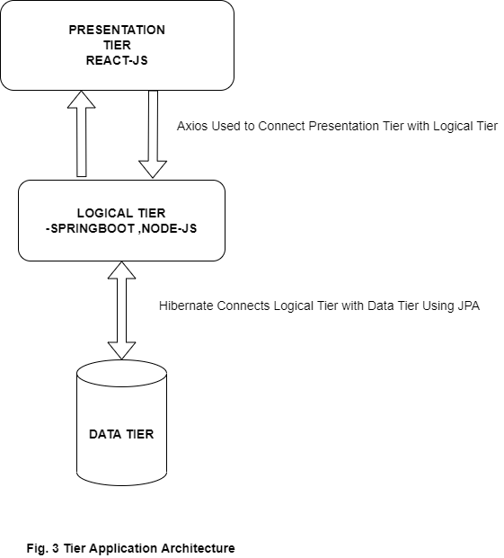

**CHAPTER 5**

**SYSTEM DESIGN**

The following description gives the general factors that affect system and its requirements.

* User can do actions such as book appointment, buy medicines and find doctors.
* User need to sign up to use book appointment feature and perform checkout.
* Non-Registered users can view features but cannot use it.
* Doctors have permission to decline the appointment.

**5.1 Project Perspectives**

* User needs to create an account to use application but account is not necessary to view features.
* Logged in user can search for doctor by city or symptom and can book appointment.
* Logged in user can use epharma portal to buy medicines.

**5.2 Use-Case Model Survey**

The use case diagrams contain two actor patient, doctor and five use case Sign Up, Log In, book appointment, buy medicines, find doctors.

**5.3 Actors Documentation:**

**1. user:**

user is an actor who will search for doctors, book appointment and buy medicines etc.

**2. Doctor:**

Doctor is an actor who will consult online with user. Doctor can also use the ecommerce part of the application.

**5.4 UML Diagrams.**

**Use Case Diagram:**

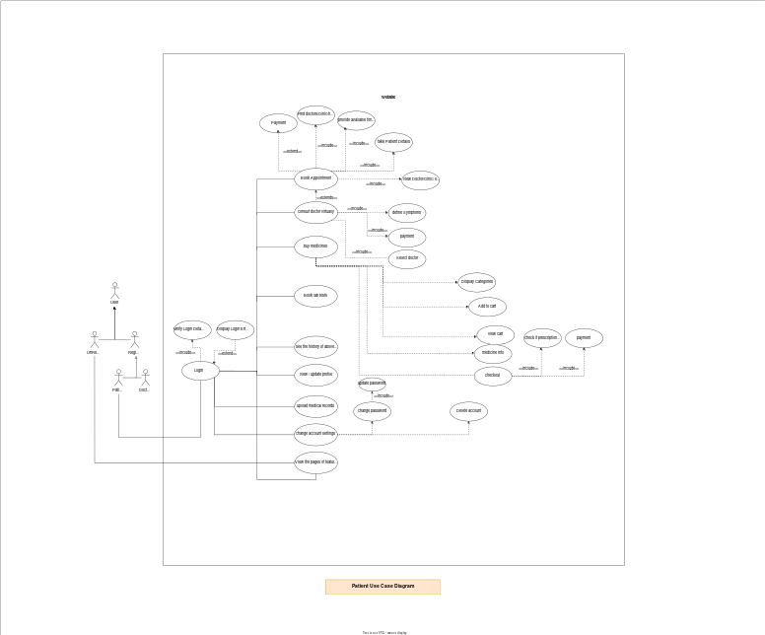

**Login Activity diagram:**

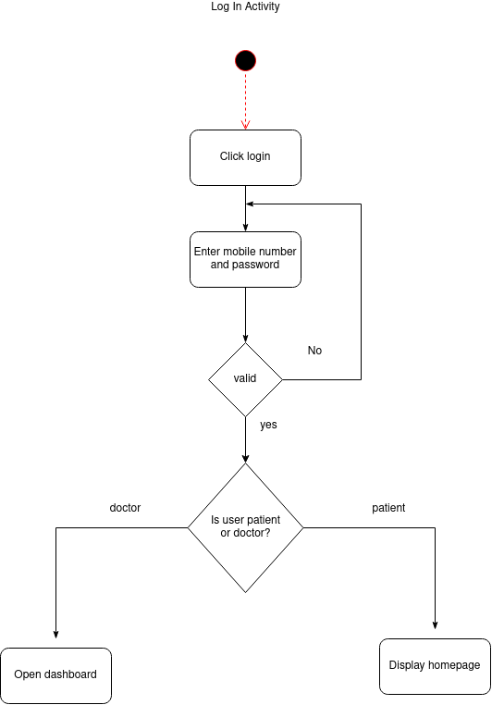

**Book appointment activity diagram:**

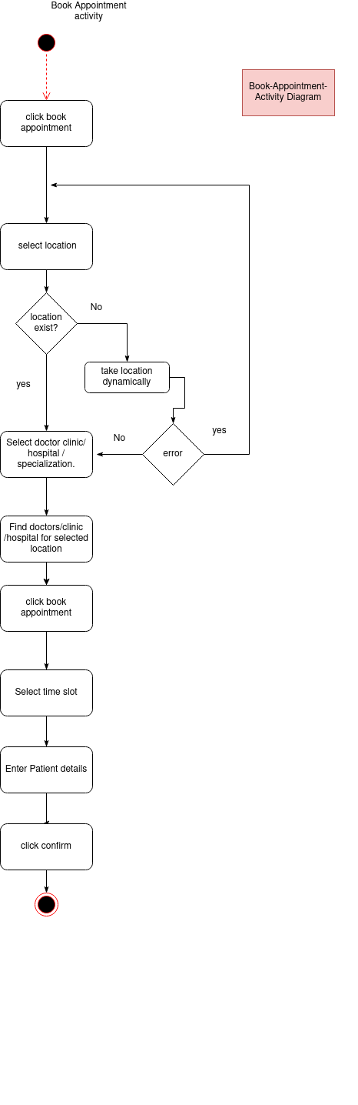

**Sequence diagram:**

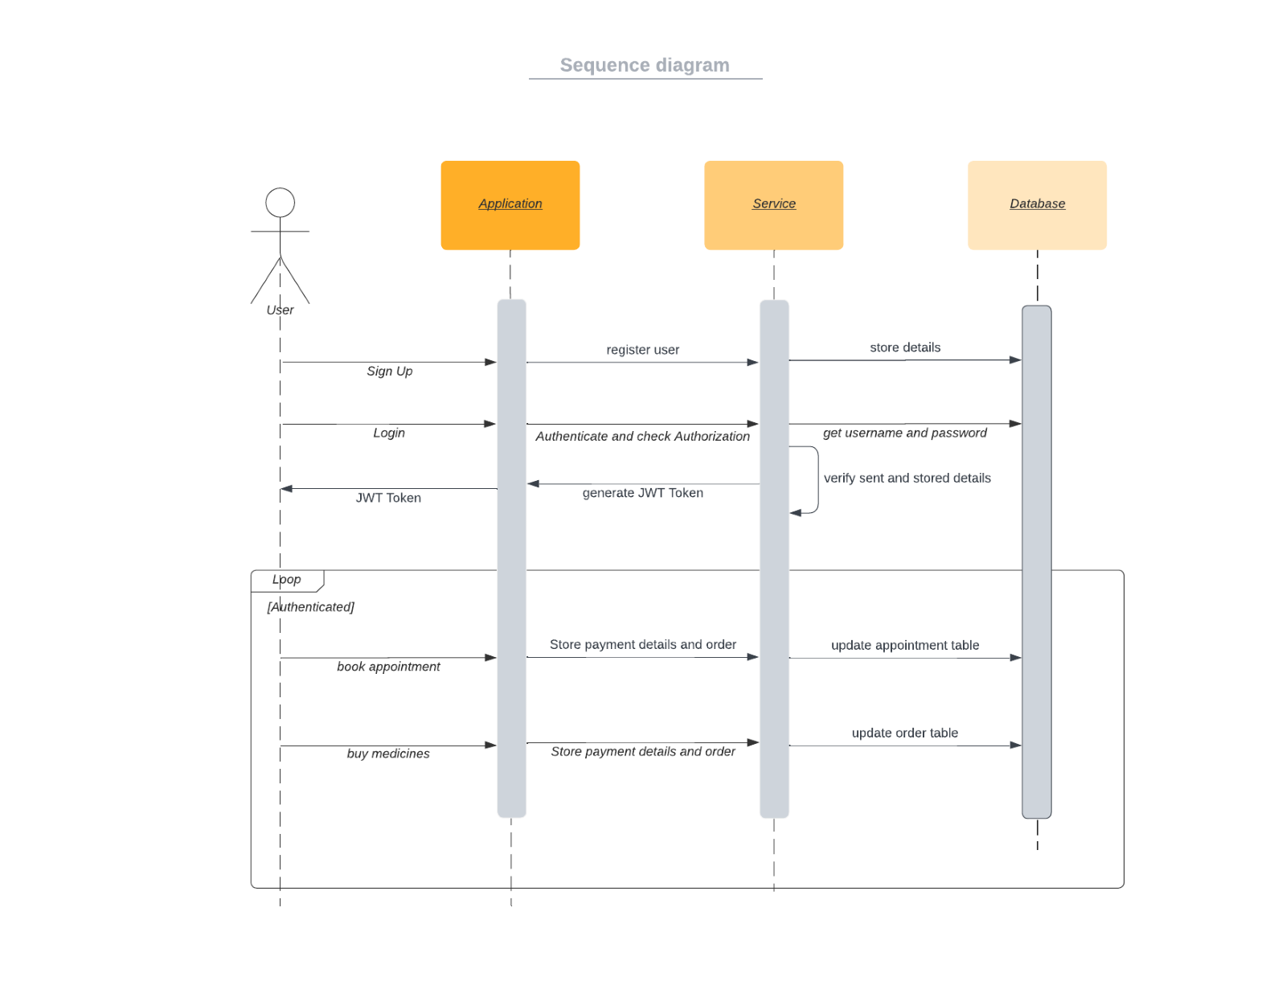

**CHAPTER 6**

**IMPLEMENTATION**

* 1. **Home page-**

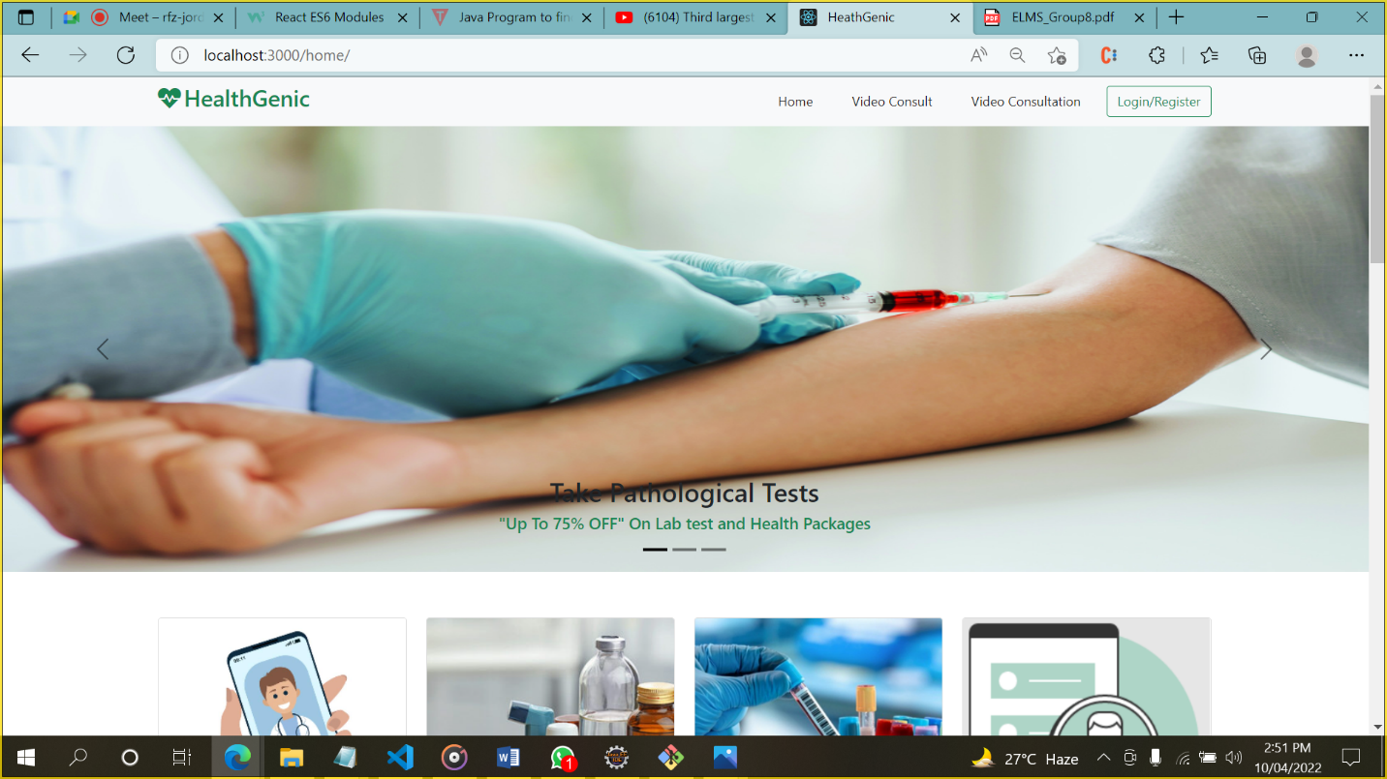

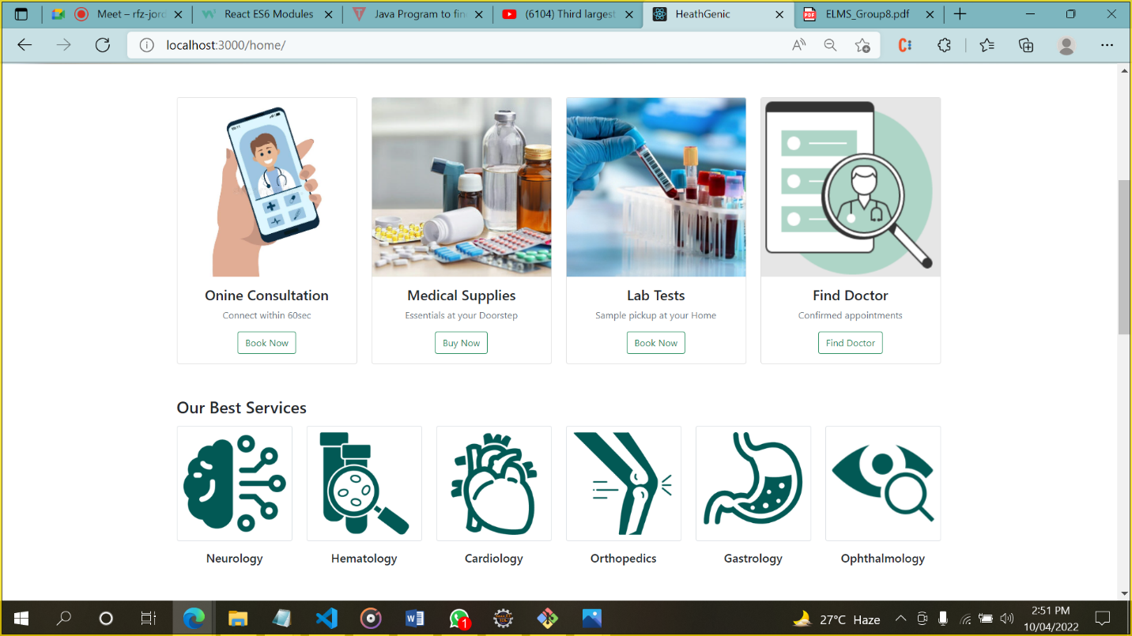

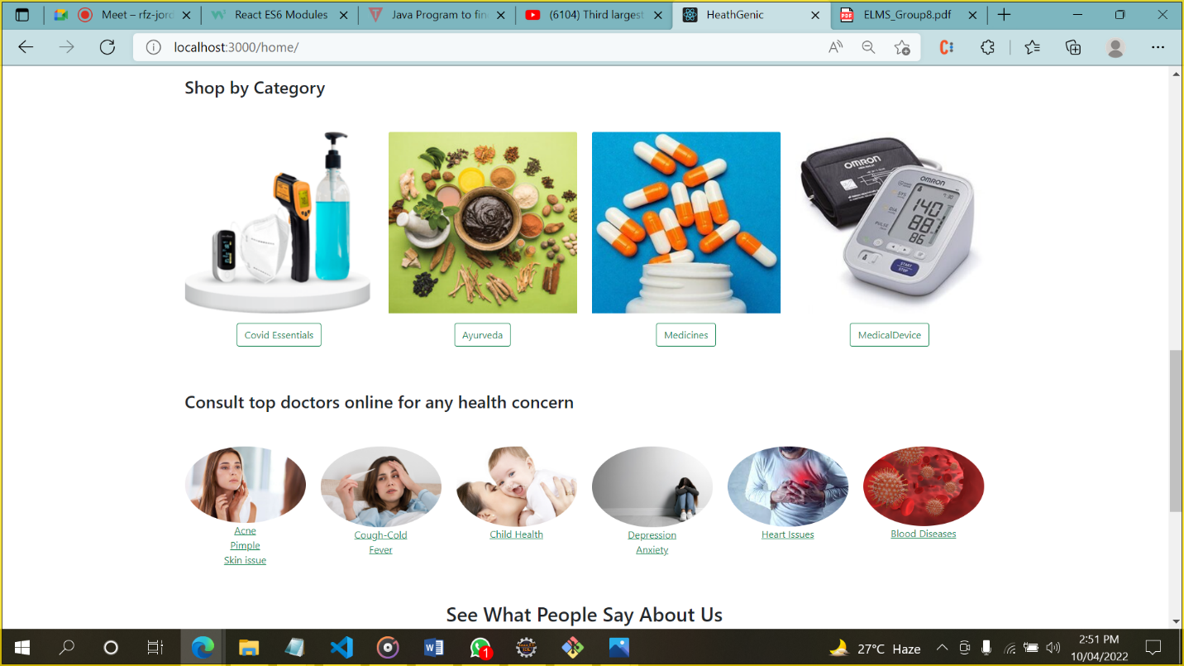

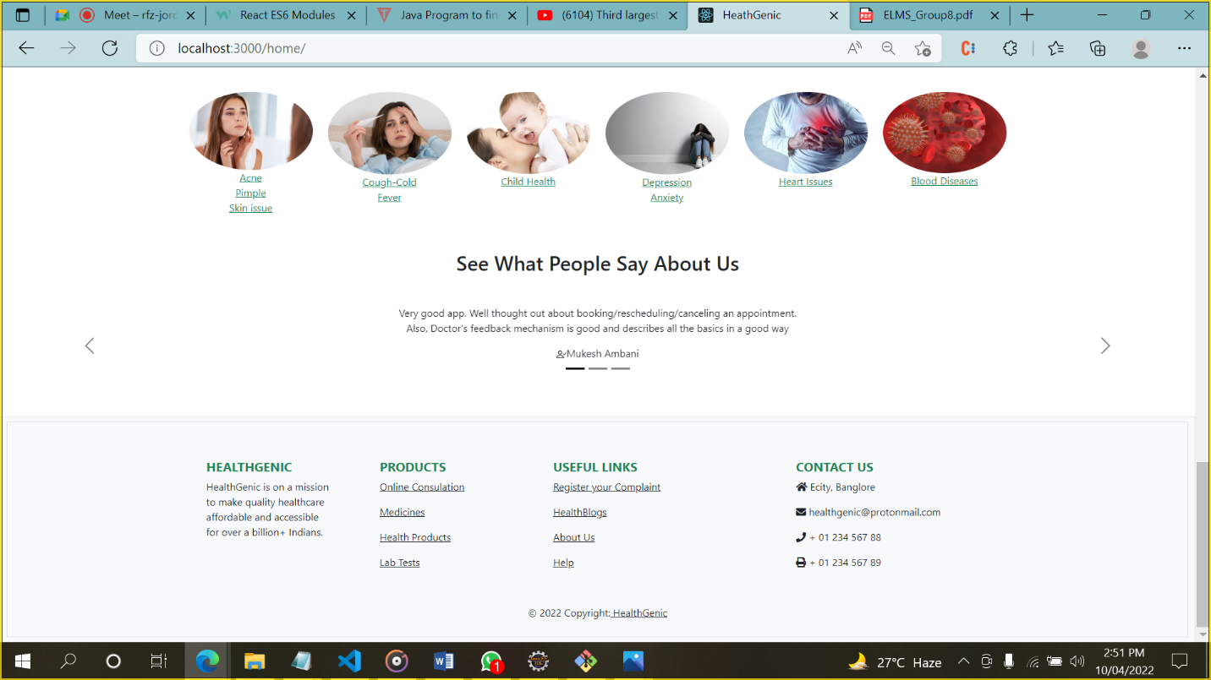

* + 1. **Login-**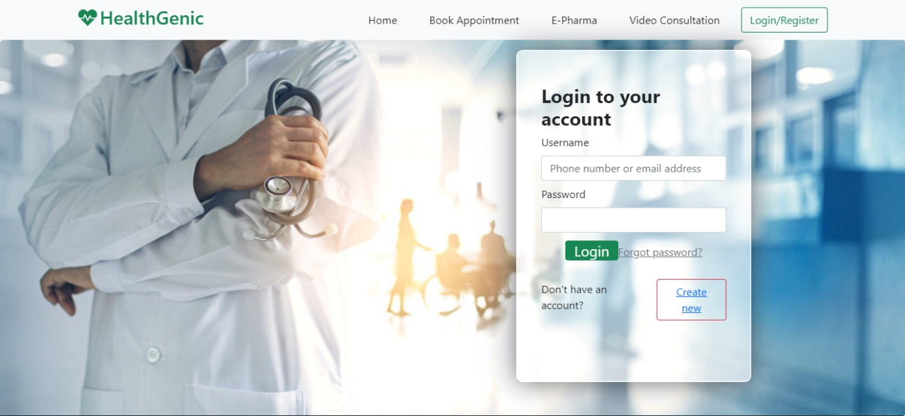
    2. **Registration**

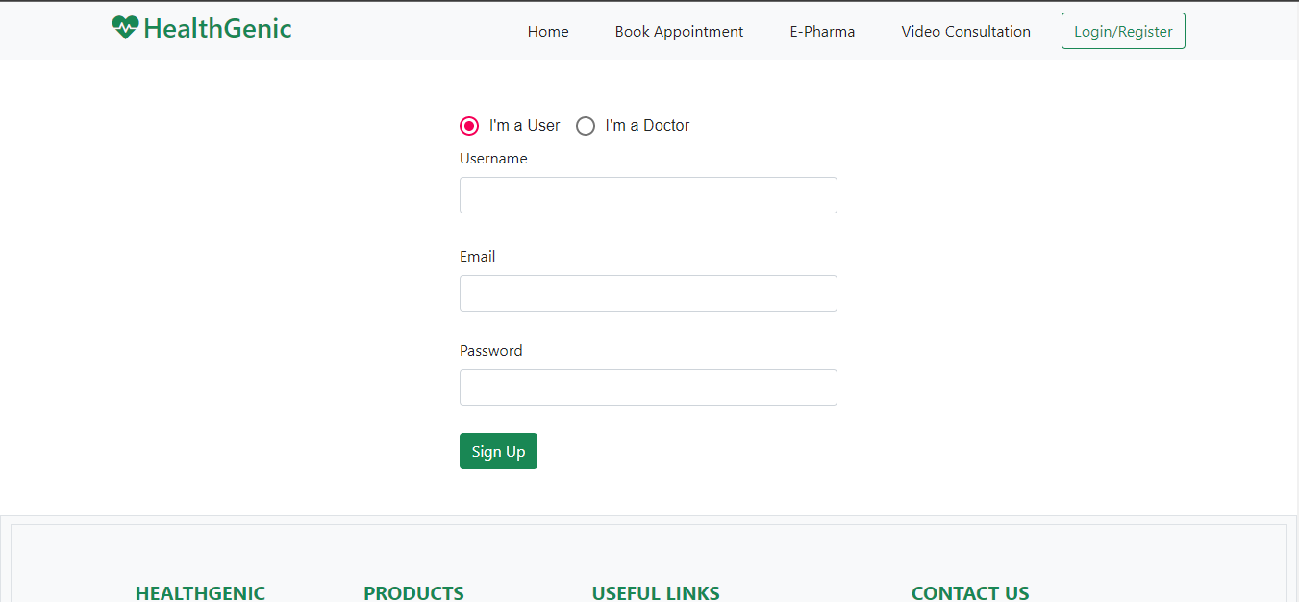

**6.2 E-Pharma-**

**6.2.1 Shop by Category**

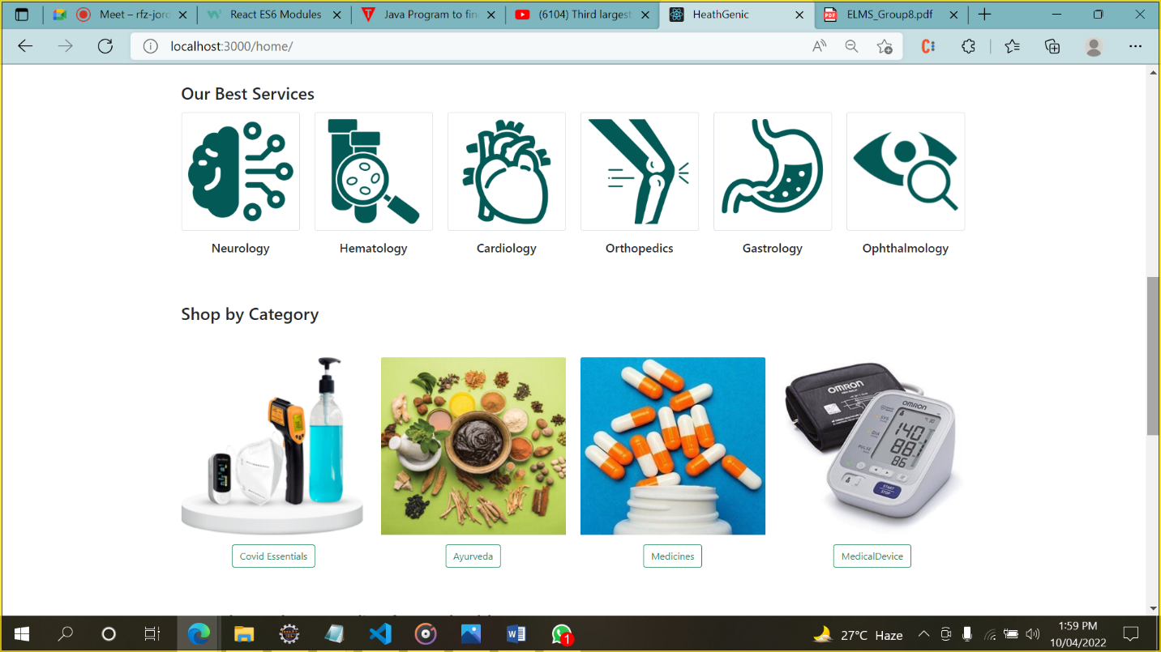

Choose Your Category to make the Wishlist.

**6.2.2 Select Your Item:**

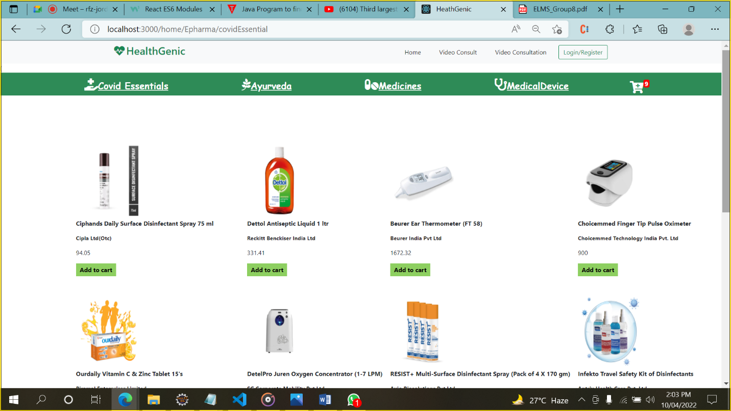

Select your favorable Products.

**6.2.3 Add To Cart:**

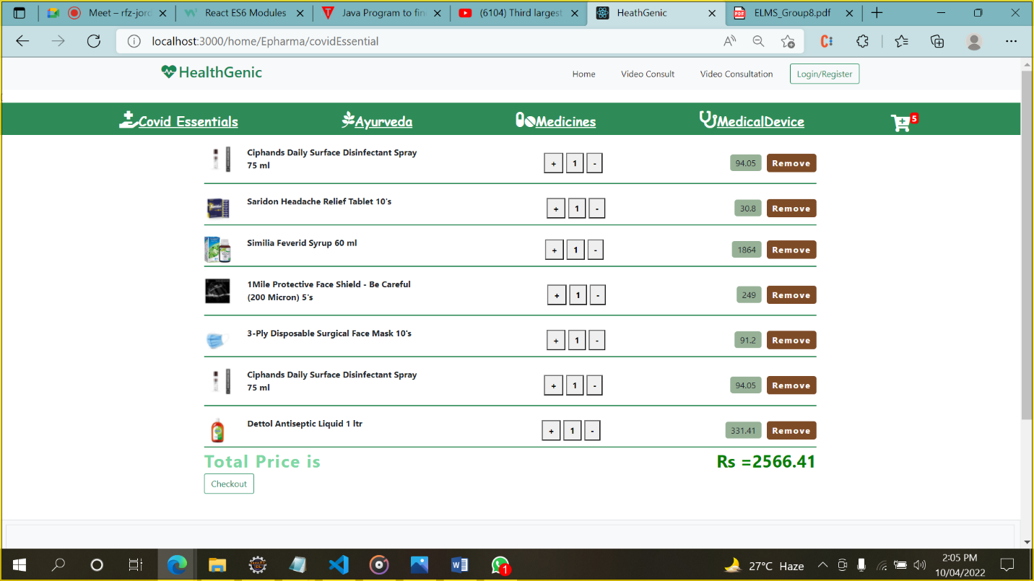

Now you have Successfully added you products make the Checkout Please.

**6.2.4- Checkout for Payment:**

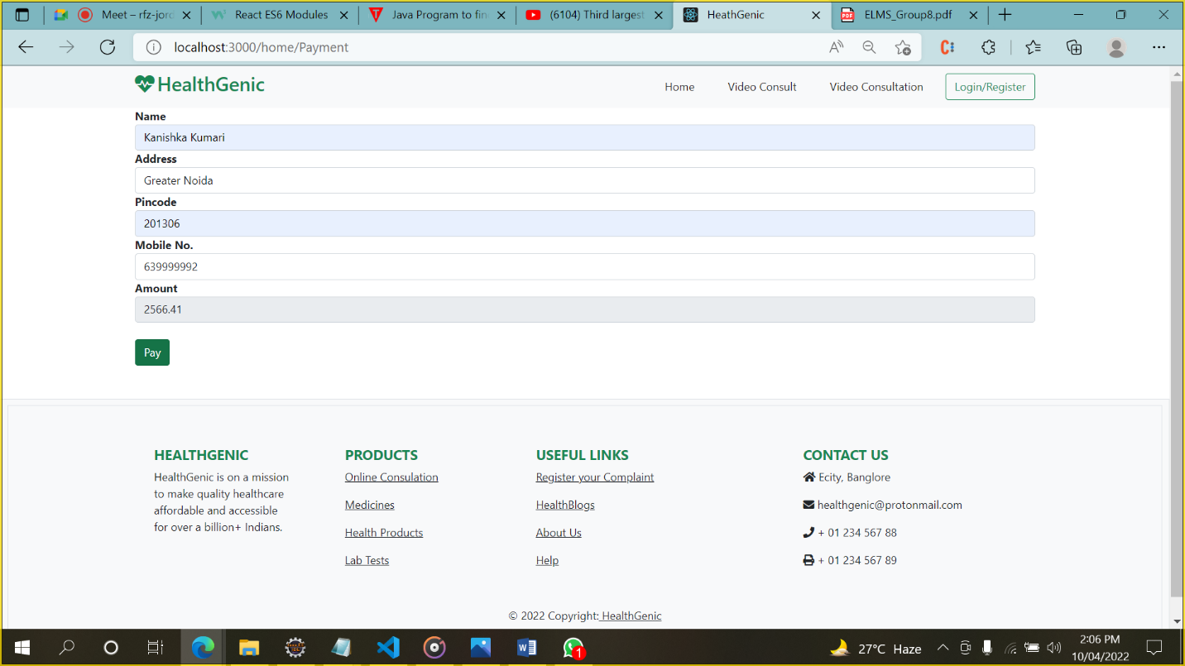

Fill Your details first.

6.2.5 Payment.

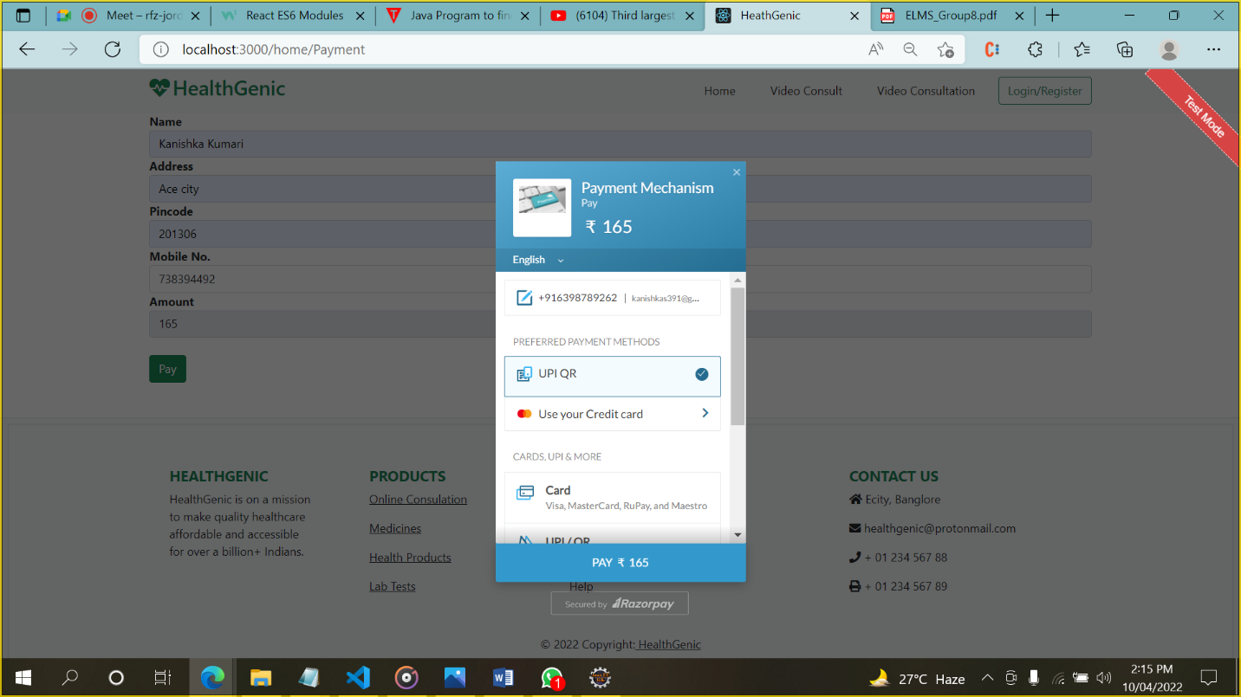

Select the payment Method such like Payment via UPI OR code, payment via Debit/Credit Cards, Payment by Master Card.

6.2.6 Payment Done 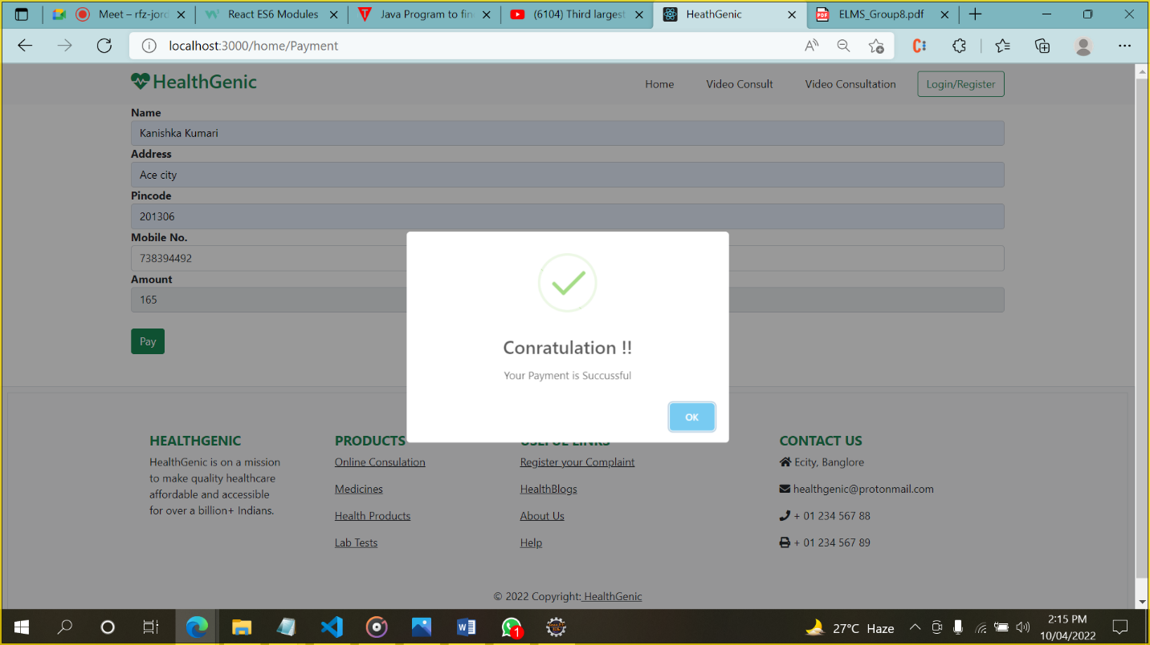

Your Payment is done Successfully.

**6.3 Find Doctor-**

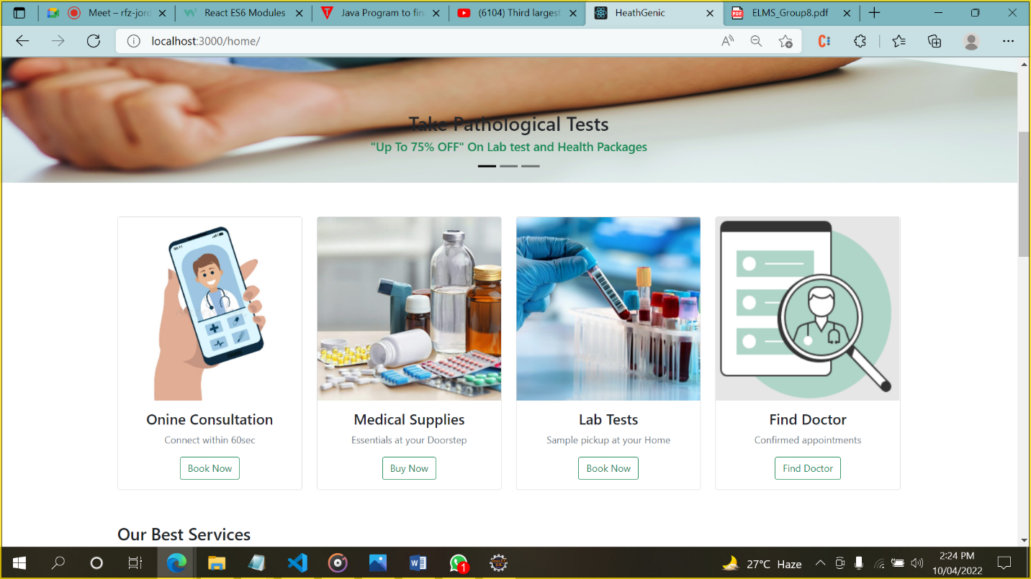Click on The Button of Find doctor to find the doctor Near You and Confirm your Appointment.

**6.3.1 Find Doctor by City And profession-**

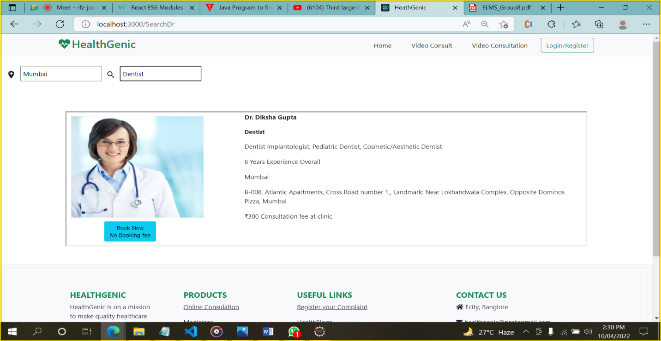

Search The Specialist According to your City.

And click on Book Now button.

**6.3.2 Book your Appointment**

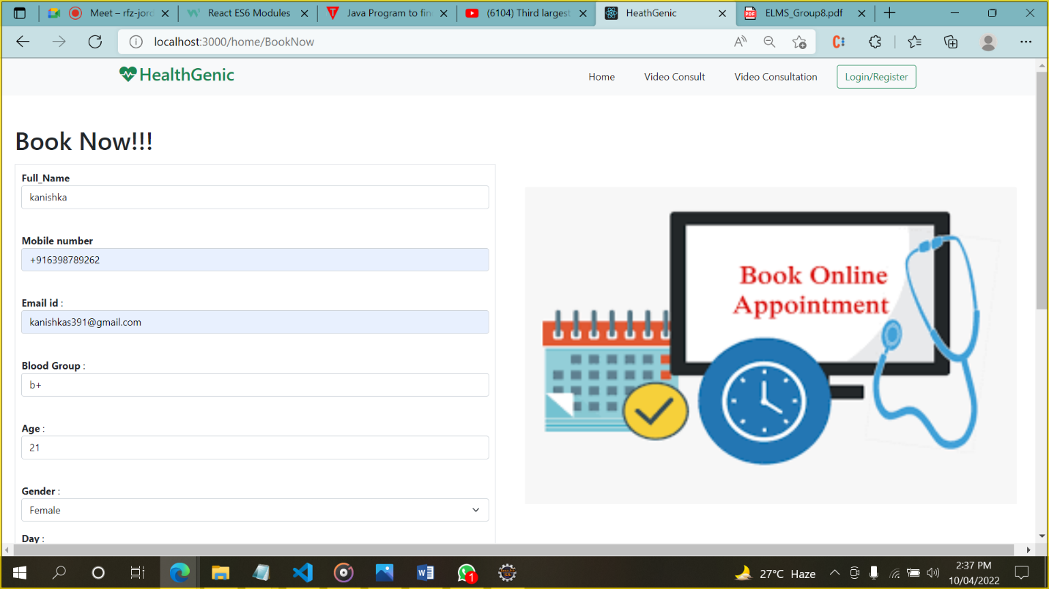

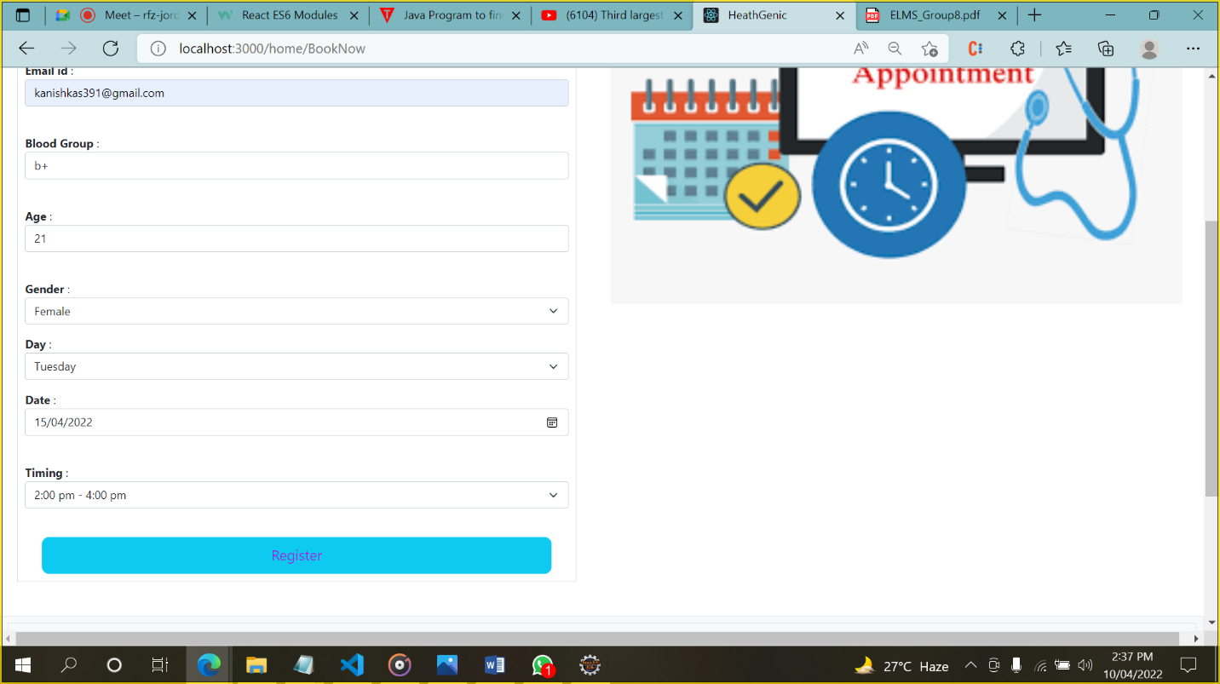

Fill up Your Details and click on Register Button To Confirm Your Appointment.

**6.4 Video Consultation-**

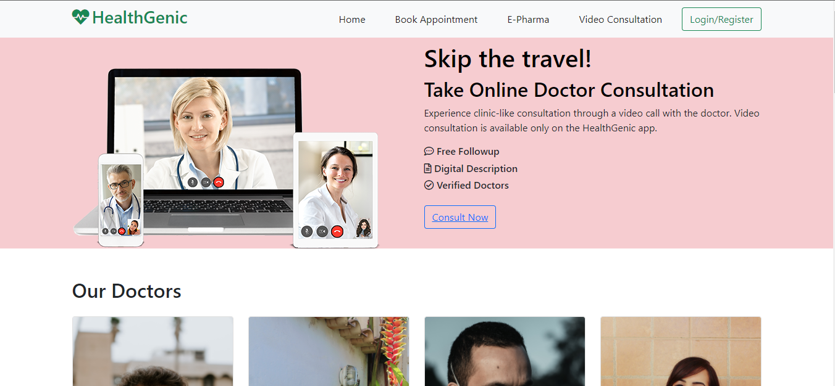

Click on Consult now to consult with your doctor online.

**6.4.1 Video Consultation**

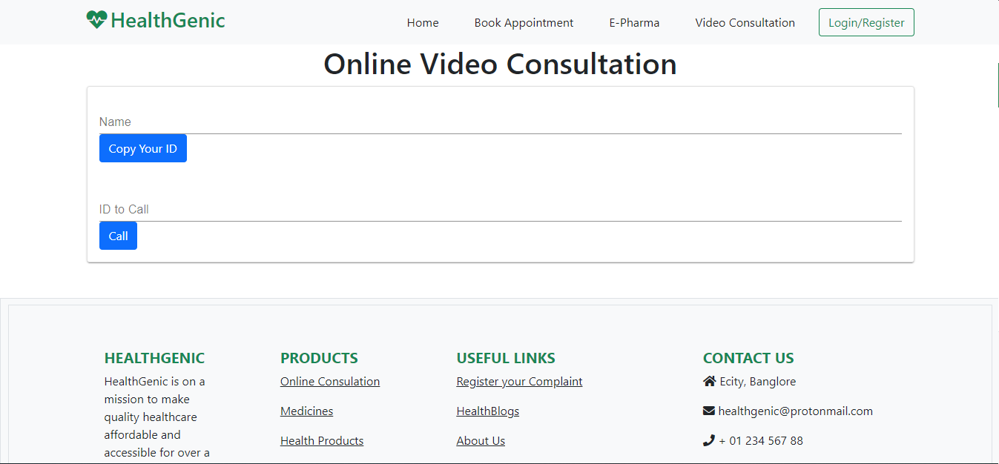Fill up these details to take the Video Consultancy with Doctor

**CHAPTER 7**

**CONCLUSION**

Online Doctor consultation made life easier and more comfortable whenever is there any kind of health issues, we can consult online doctor at affordable cost. Online Consultation is reliable because everyone has some health problem and in this modern era, we are just one step away and can consult through online doctors. Online book appointment for better organization of time for staff and patients with less waiting time.

**Chapter 8**

**REFERENCES**

* <https://www.practo.com/>
* <https://www.lybrate.com/>
* <https://www.netmeds.com/non-prescriptions/covid-essentials/mask-gloves-protective-equipment>
* Introduction to Health Care Management Sharon B. Buchbinder, Nancy H. Shanks, Bobbie J Kite
* Clinical Anaesthesia Procedures of the Massachusetts General Hospital
* Richard M. Pino MD PhD